Purpose:

My goals for this site are to create an online resume that shows my skills as an individual to any employers who look at the site. I’m choosing to create this site as the culmination of the things I have learned the past four years and wish to use them to find myself a job after graduation. The scope of my project is to show who I am, what I have done, and what I want to do for a living. To achieve this, I will include information about myself, show past projects and information on current projects, along with a formal resume to be viewed as well. My audience will be any potential employers that I will be sending my resume to, or any friends or family that I ask to critique it.

Navigation:

1. Home
   1. Resume
      1. Download Resume
   2. About
   3. Past Projects
      1. Project 1 Github/Download
      2. Project 2 Github/Download
      3. Project 3 Github/Download
   4. Future Projects

Sketch:

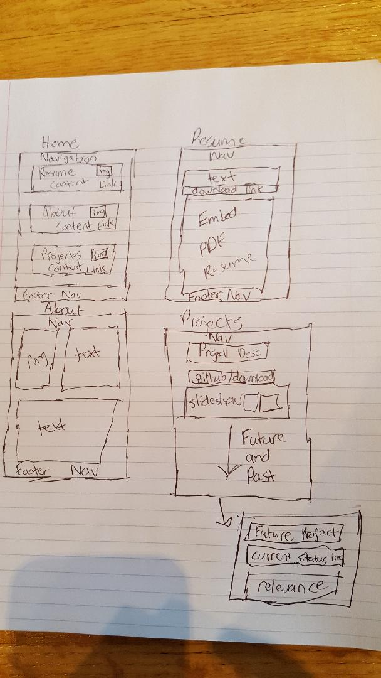

Content:

Home:

1. Brief Resume Text
2. Brief About Text
3. Brief Past Projects Text
4. Brief Future Projects Text
5. Picture of me for about
6. Picture of my resume
7. Screencap of a past project
8. Screencap of a current/future project

Resume:

1. Embedded view of my resume
2. Link to download it as a pdf
3. Brief text explaining how to download or view it at the top

About:

1. Picture of myself
2. A couple paragraphs of text about who I am

Past Projects:

1. Video link of Project 1 demonstration
2. Gallery/Slideshow of pictures showing functionality of Project 1
3. Github Link Project 1
4. Project 1 Description
5. Video link of Project 2 demonstration
6. Gallery/Slideshow of pictures showing functionality of Project 2
7. Github Link Project 2
8. Project 2 Description
9. Video link of Project 2 demonstration
10. Gallery/Slideshow of pictures showing functionality of Project 2
11. Github Link Project 2
12. Project 2 Description

Future Projects:

1. Text explaining current project/projects
2. Any current video or image demonstration
3. Text explaining importance

All of the photographs and videos are going to be created by me. I am unsure if I will use videos or not at this point, but I may end up creating them in case I want them anyway. I will need a picture of myself, and screencaps of parts of my project along with a screencap of my resume.

The most important content will be my resume, in order to make it look professional and web accessible, after that will be showing off previous and current projects that I am working on. The about me section isn’t all that important, but it can provide them a bit of background about me if they are interested in learning more.

For my pictures I will likely use one of the carousel plugins since I like the look of scrolling through the images, and will probably use the video embed if I end up using video demonstrations for my projects. As of now I don’t have anything else planned but as I create the actual page I may upgrade or change sections if they don’t turn out as desired.

Brand/Look and Feel

For the look and feel I want to create a site that directs your attention straight to the content. I want the user’s eyes to go directly to my resume and projects that I have worked on because I have a very limited amount of time to catch a potential employers attention. If they have to spend any time at all looking for what they want, they will simply pass over my application. For this I want the background to be a little duller and have the content pop out more, or be accentuated. I think having some lighter blues in the background will make the site seem professional and somewhat dignified compared to a bright color you might expect from something like a social media site. I want it to feel like the site itself is just a vessel to show who I am and what I can do, without the focus being on the site itself.

For a logo I will just be using my name and try to style it to grab your attention and have that serve as the logo. I think having a logo for a resume would look tacky and instantly reduce my chances of it being viewed.

Styles: 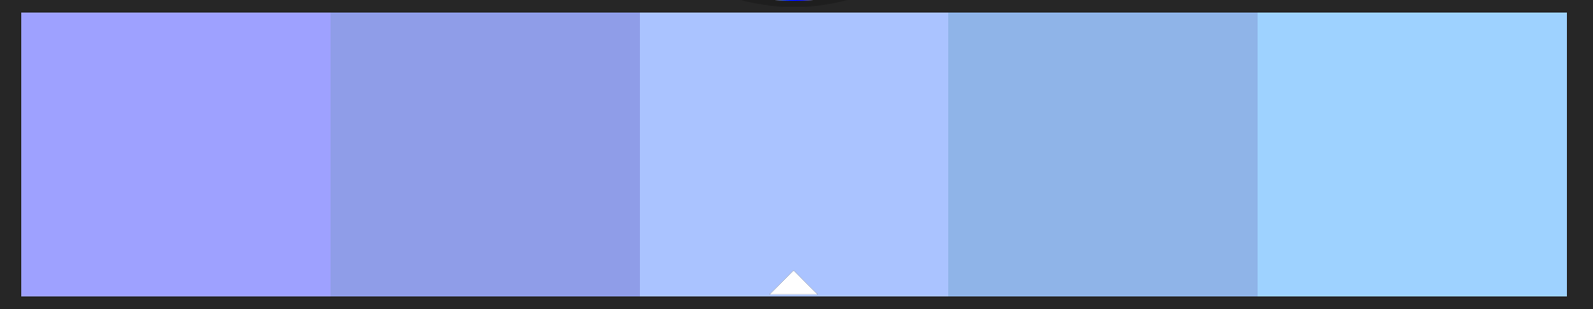

This is a rough idea of the color scheme I am looking for, having dull tones in the background will make the content pop out more.

Typography:

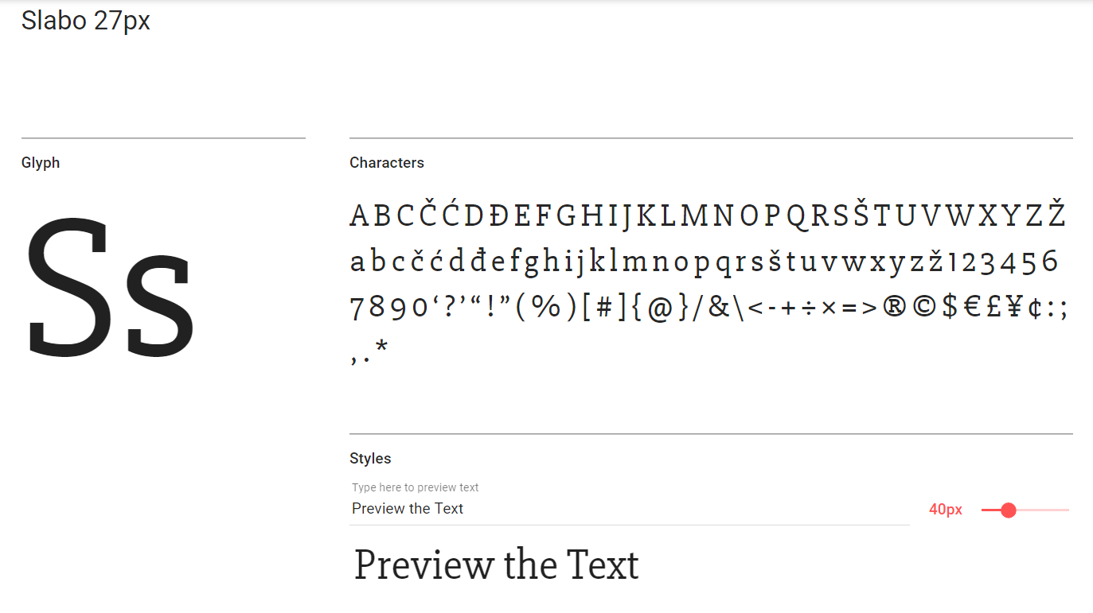

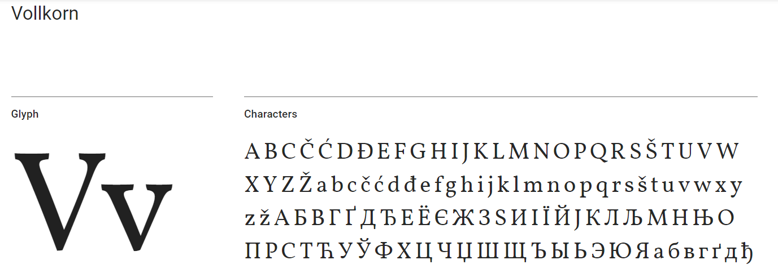

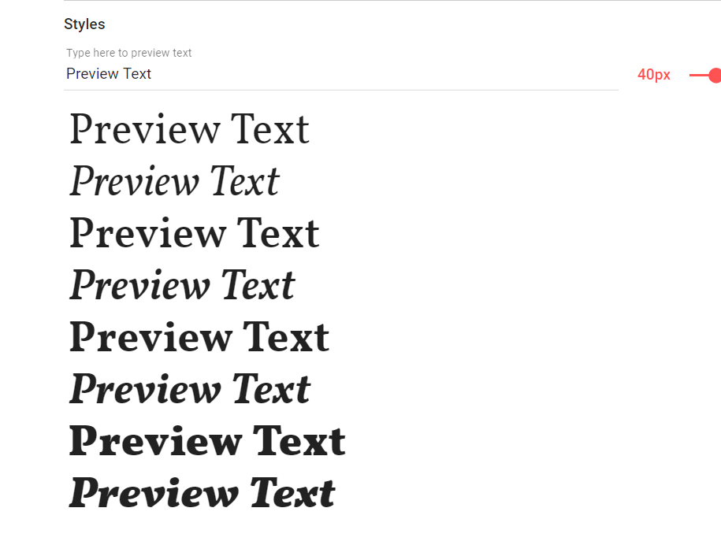

Texture/Pattern

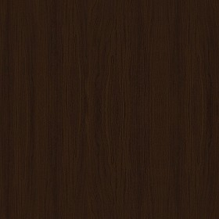

I like the seamless dark wooded textures, they are subtle yet add a lot of character to the content they display

Design elements:

The navigation at the top and at the footer will remain the same for all the pages, and I will likely have the content blocked together because uniformity can help dissuade the user from being confused on what they are looking at or looking for.

Descriptors:

Subtle, Simple, Ordered, Clean, Quick, Serious, Expressive